|  |
| --- |
| **FlyAway**  **(Application Screenshots)** |

**Version History:**

|  |  |
| --- | --- |
| Author | Jaydeep K Mandal |
| Purpose | Screenshots of the application |
| Date | 15th January 2023 |
| Version | 1.0 |

Table of Contents

1. Landing Page 3

2. Travel Details 4

3. Traveller Details 5

4. Checkout 6

5. Confirmation 7

6. Admin Login 8

# Landing Page

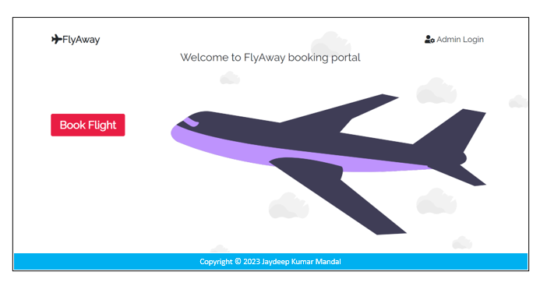

# Travel Details

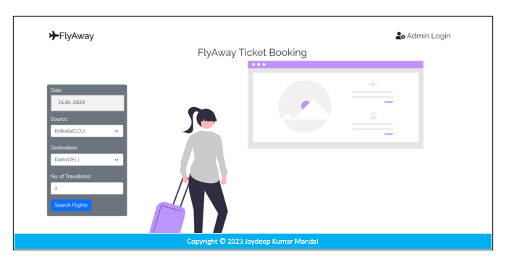

# Traveller Details

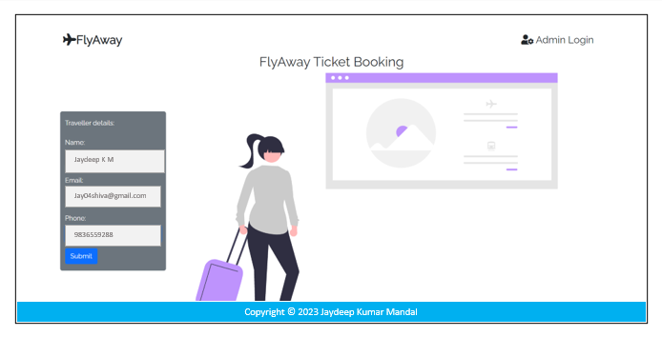

# Checkout

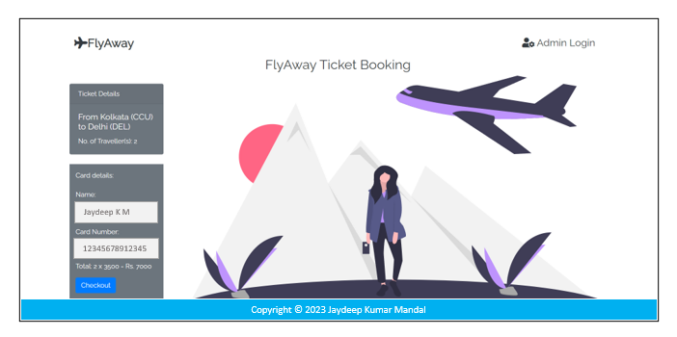

# Confirmation

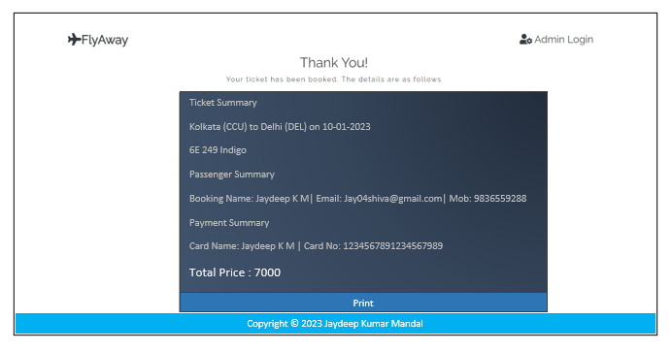

# Admin Login

